Design Documentation

Bluetooth Section:

Introduction:
The TC35678FSG is the bluetooth interface for the Atmel SAM9N12 in this case. The TC35678FSG works with 3.3V. The system requires 2 crystal oscillators 26MHz reference clock and 32.768kHz sleep clock. The connection between the Atmel SAM9N12 and the TC35678FSG is described in the block diagram.

Block Diagram:
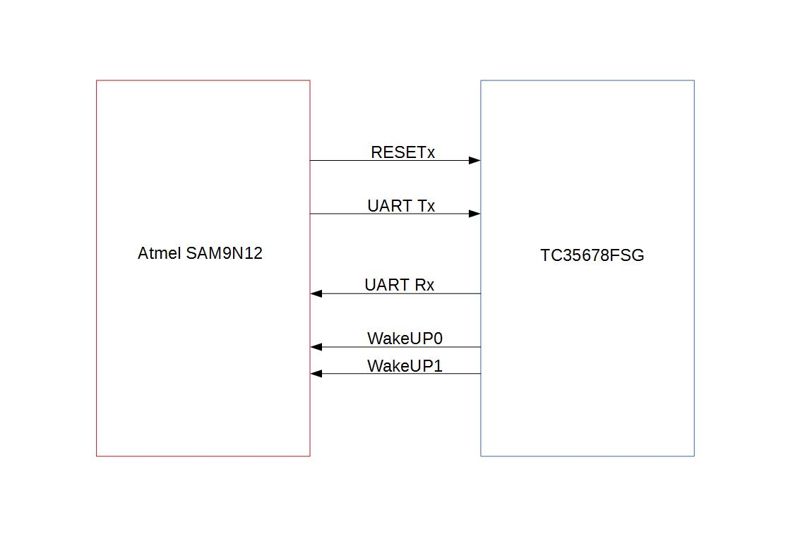

Note:
# The RESETx should be controlled in order to enable and disable the system.

Figure(1): Block Diagram of the Bluetooth Interface.

DDR2 memory Section

Introduction:

